PROJECT REPORT

# **PROJECT TITLE:** Plugging into the Future: An Exploration of Electricity Consumption Patterns

# **TEAM ID**: NM2023TMID32189

# **TEAM MEMBERS:** DHANUSHYA.R

EBIN VINOGEYA.N

MUPPIDATHI.K

SAYINI.S

# **1. INTRODUCTION**

**1.1 Overview**

The respective project defines about the consumption of electricity under the following factors such as state wise, region wise, year wise ( 2019 & 2020 ) and also the dataset is given under latitude , longitude , usage . Overall, the output of the respective project may help the respective workspaces to analyze the data easier through bar diagrams , pi-charts , maps and vice versa than from paragraph format .

**1.2 Purpose**

The primary purpose of the plugging into the future : an exploration of electricity consumption patterns is to help the workspaces under electricity consumption to deduct and analyze the usage of electricity in our daily life . Our main is to increase the electricity production at cheapest cost . This analysis should help the workers under certain departments to obtain a better idea.

# **2 . Problem Definition & Design Thinking**

**2.1 Empathy Map**

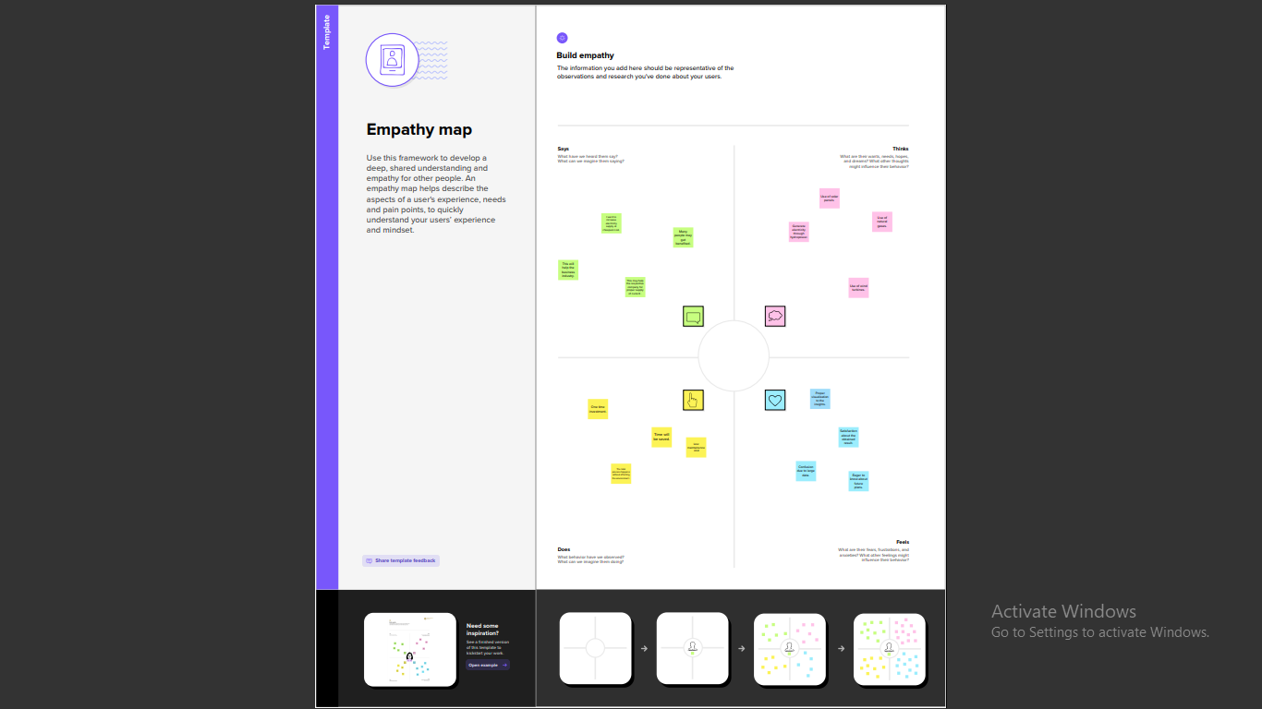

**2.2 Ideation & Brainstorming**

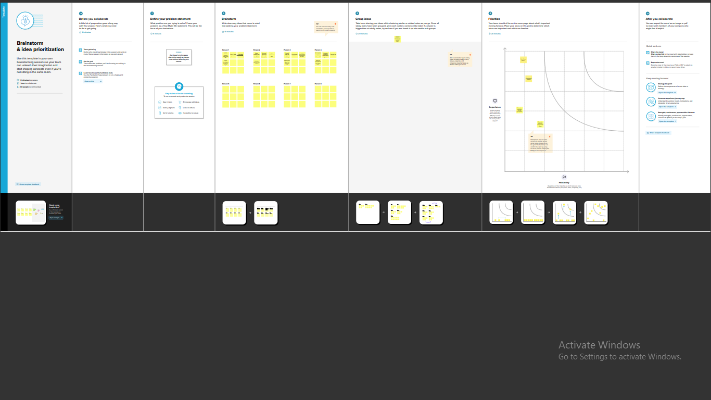

# **3. RESULT**

**Dashboard:**

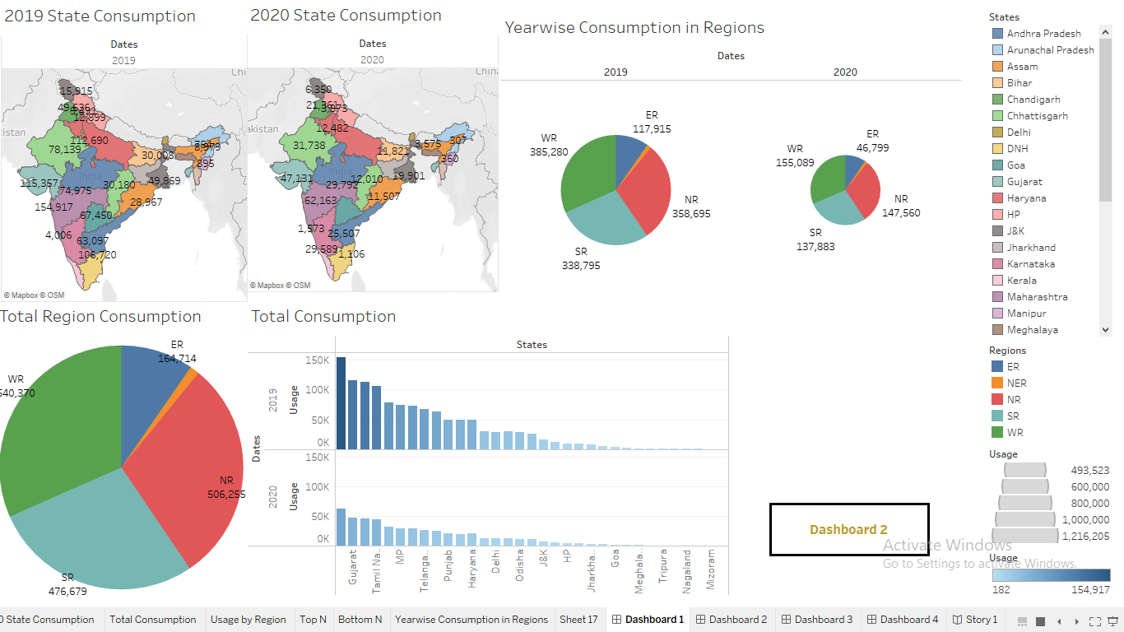

**Story:**

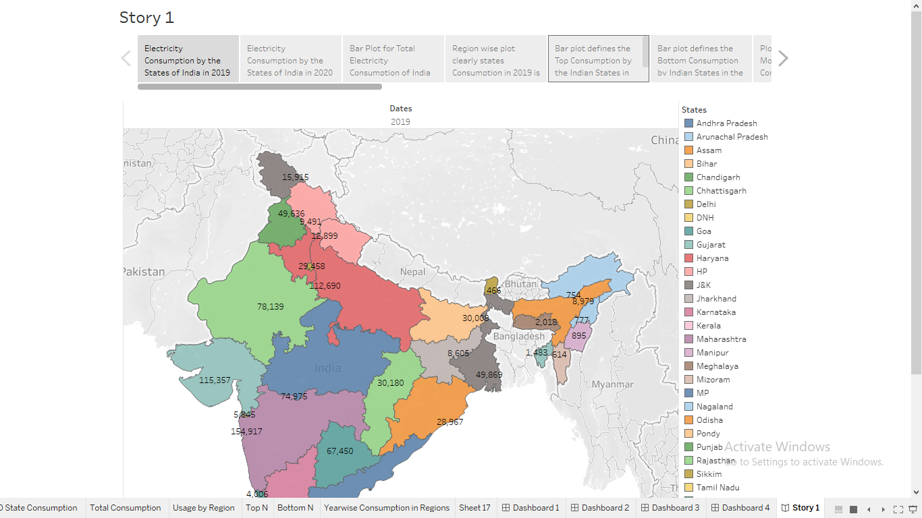

**Sheets:**

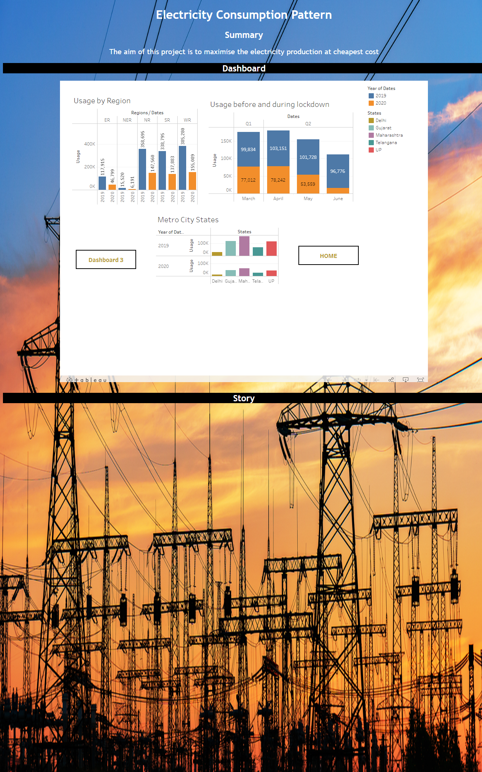l,;lljgv

**4 . ADVANTAGES & DISADVANTAGES**

**Advantages of using Solar Panels:-**

* Reduces Electricity Bills

* Diverse Applications

* Low Maintenance Costs

* Technology Development

**Disadvantages of using Solar Panels:-**

*Weather Dependent

*Solar Energy Storage is Expensive

* Uses a Lot of Space

* Associated with Pollution

**5. APPLICATIONS**

We use solar panels to generate electricity. This process can take place either for domestic or industrial purposes. For the renewable energy available, the sun is the purest source. Solar powered photovoltaic panels convert the rays of the sun into electricity. In this process, electrons get excited in the silicon cell using the photons from sunlight. Solar energy is the supplement of many farm energies. Solar panels can be applied in different forms of products which includes solar cooker, solar water heater, solar lamp, solar still, solar furnace, photovoltaic power station and vice versa.

**6. CONCLUSION**

Electricity consumption can be reduced when solar panels are used. Residential sector is the highest consumption of electricity in India it can be controlled by using solar panels in residents. Electricity can be consumed for future when solar energy and electricity energy are used equally. Solar energy is the energy that the sun gives to the earth in visible and electromagnetic forms. We use solar panels to convert that light into electricity, which is then used to provide the power of electricity loads. The process can take place both at a solar and industrial scale.

**7. FUTURE SCOPE**

**Enhancements that can be made in the future:-**

In coming years, technology improvements will ensure that solar becomes even cheaper. Solar power is a fastest developing industry in India. Solar panels can be used in all residents so that electricity can be consumed in summer season and can also be used in rainy season. Different types of solar energy can be developed all over India. By the invention of more solar equipments which replaces electricity. Previously, the average efficiency of solar panels was around 15%, but now the advancements in photovoltaic technology, the efficiency of solar panels is currently between 15-20%. High-efficiency solar panels can even reach nearly 23%.

**8. APPENDIX**

